Sources
Du Plessis, Sophia, and Stan Du Plessis. “Happy in the Service of the Company: The Purchasing Power of VOC Salaries at the Cape in the 18th Century.” Economic History of Developing Regions 27, no. 1 (2012): 125–49. https://doi.org/10.1080/20780389.2012.682398.

https://visit.museum.wa.gov.au/batavia-ebook-2022-web/Batavia_ENG_01-62.xhtml
Musicians on the VOC ships:
- The ship’s trumpeters were important crew members aboard the VOC ships during the seventeenth century. Most ships carried at least one trumpeter, sometimes even three. These multi-talented men were well paid and wore distinctive uniforms.
- given responsibility to deliver important messages: often required to negotiate with Indigenous leaders
- In many cases they were not hired for their musical ability -> as trusted assistants for the ship’s captain
- trumpet: signal other ships about their way to go
- signalled the arrival or departure of important visitors to the ship, the change of watch, meal and prayer times.

https://www.academia.edu/37278348/The_Use_of_Trumpet_on_Board_ships_of_The_Dutch_East_India_Company
The “untrained” [nicht gelernter] on the contrary, is only capable of sounding the necessary signals. The ship’s trumpet player may well be considered a kind of field trumpet player whose major duty was to sound signals to the crew and to other ships.
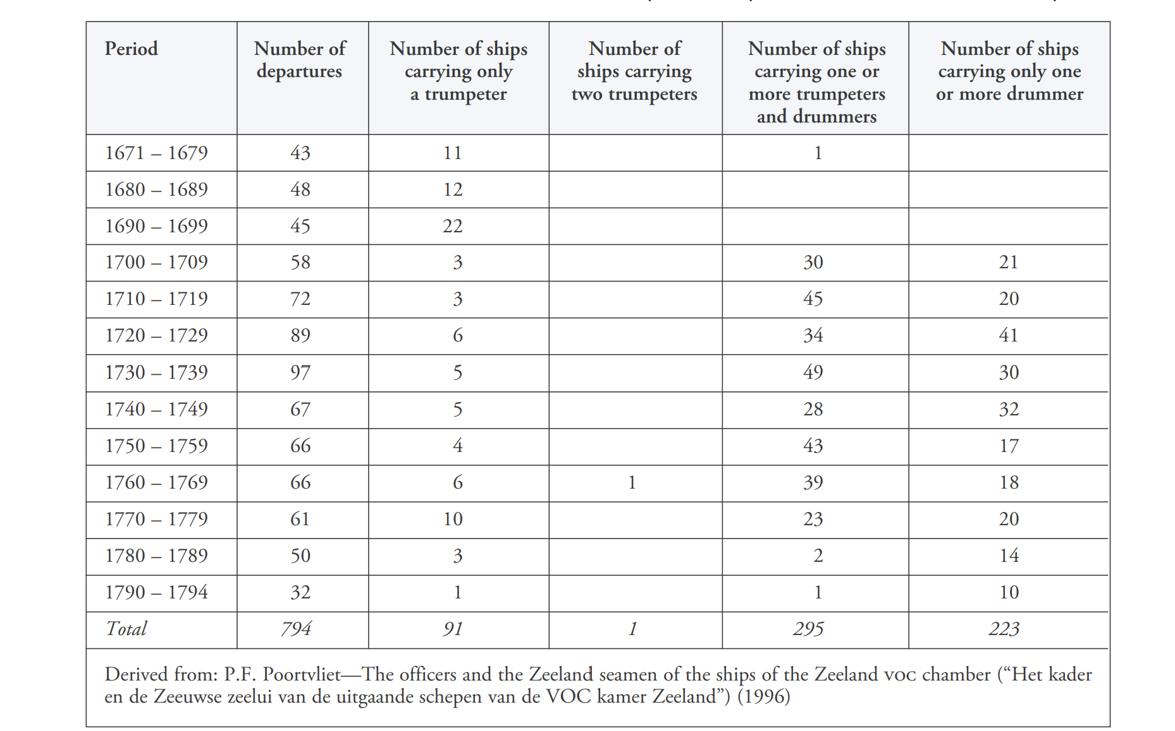
- trumpet: means of communication
- Because a drummer had a lower rank than a trumpeter (and accordingly received less salary) it is not surprising that there were more ships that carried only a drummer than ships with just a trumpeter.

https://www.theweek.in/news/entertainment/india-cultural-relations-with-dutch-east-india-company-spotlight.html
“Ooijen will make a short lecture-concert programme with a 'soundscape' of the music that might have been heard on the streets of the Dutch settlements in India.”

